Problem: Hospital staff often need to manually monitor patient flow and resource availability, making it difficult to anticipate congestion and resource shortages in advance, resulting in delayed operational decisions and inefficient resource utilisation.

This system is not a doctor, a patient chatbot, a diagnosis system or an autonomous system making medical decisions. Instead, it continuously monitors hospital resources and patient flow, predicts upcoming congestion or demand, optimises resources, and assists hospital staff in taking timely actions

Synopsis: The system continuously monitors patient flow and hospital resources, predicts congestion or demand, and analyses current and predicted conditions to identify operational needs. It prioritises these needs and provides actionable recommendations to optimise resource utilisation, and also assists hospital staff in taking timely decisions through a Human-in-the-Loop approach.

What operational areas will we be managing?
We will be managing four operational areas:
- Patient Flow: Arrivals, waiting, admissions, discharges, transfers, and department congestion will be managed.
- Bed & Resource Management: Bed occupancy, ICU capacity, and equipment availability will be managed.
- Staff Management: Doctor/nurse availability and shift capacity will be managed.
- Incident & Operational Coordination: Bottlenecks, alerts, and recommendations will be managed.

What will we be implementing in Project I? (We can’t be doing all at once)
We are not trying to manage the entire hospital at once. For Project I, our implementation will primarily demonstrate patient-flow monitoring, bed and resource monitoring, prediction, and congestion detection with recommendations.
- Patient Flow Monitoring
The system will monitor:
- Patient arrivals
- Patients waiting
- Patients being treated
- Admissions
- Discharges
- Transfers
- Waiting time
Note: A dashboard shows this data, which gives an operational view of the entire hospital.

FYI: Patient Flow
Arrival → Registration → Waiting → Doctor → Tests → Treatment → Admission/Bed → Discharge
- Bed/Resource monitoring
The system will continuously monitor the hospital’s resources and record them.
- ML Prediction
Two Predictions to be performed:
- Prediction A: Patient Arrivals
- Prediction B: Bed Occupancy
Note: A separate card for the prediction section.
- Congestion Detection & Recommendation
The system identifies potential congestion or demand and then produces a recommendation.
Note: ML predicts the situation, the system determines whether it's a problem, and the recommendation system suggests what the staff should consider doing.

What is the Agent’s role in this system?
The agent acts as an operational decision-making layer between the hospital data/ML models and the staff.
The agent will:
- Observe: Check patient flow, bed availability, occupancy, predicted arrivals, etc.
- Understand: Combine current data with ML predictions.
- Reason: Identify problems such as “Emergency department may become overcrowded.”
- Plan: Determine what information/actions are needed.
- Recommend: Suggest actions to the hospital coordinator.
- Act with approval: Execute authorised actions after human approval (human-in-the-loop).

How will this system do coordination?
The system does coordination by connecting information, decisions, and actions across hospital departments.
Suppose ML predicts patient arrivals will increase, and the bed model predicts capacity will reach 95%, then:
The agent will investigate and create a plan, then seek human approval, and the system will coordinate the actions, like sending notifications to the relevant staff, creating tasks, and recording what was done.

Scenarios that allow better understanding of this project:
Scenario 1: Emergency Department Congestion
Suppose it is 6 PM
The system sees:
- Emergency department occupancy is 85%
- 8 beds currently available
- Patient arrivals have been increasing
- Several patients are expected to arrive in the next 2 hours
The ML model predicts that the Emergency Department occupancy may reach 96% within the next 2 hours.
Then the agent investigates:
- How many beds are available?
- How many patients are expected to arrive?
- How many patients are expected to be discharged?
- Is capacity available in another relevant ward?
It concludes and recommends:
High congestion risk. Recommend preparing 3 additional beds and notifying the emergency coordinator.
The system will seek human approval, and then after approval, the system will:
- Send the notification
- Create an operational task
- Update the dashboard
- Record the actions
Scenario 2: ICU Resource Shortage
Suppose ICU occupancy is 90%.
The ML model predicts that ICU occupancy may reach 98% within the next 4 hours.
Then the agent investigates:
- Current ICU beds
- Expected admissions
- Expected discharges
- Available resources
- Current operational constraints
It identifies any shortage and recommends:
ICU capacity is expected to become critical. Two beds should be prepared, and the ICU coordinator should be alerted.
The system will send the alerts and create the corresponding task after human approval.
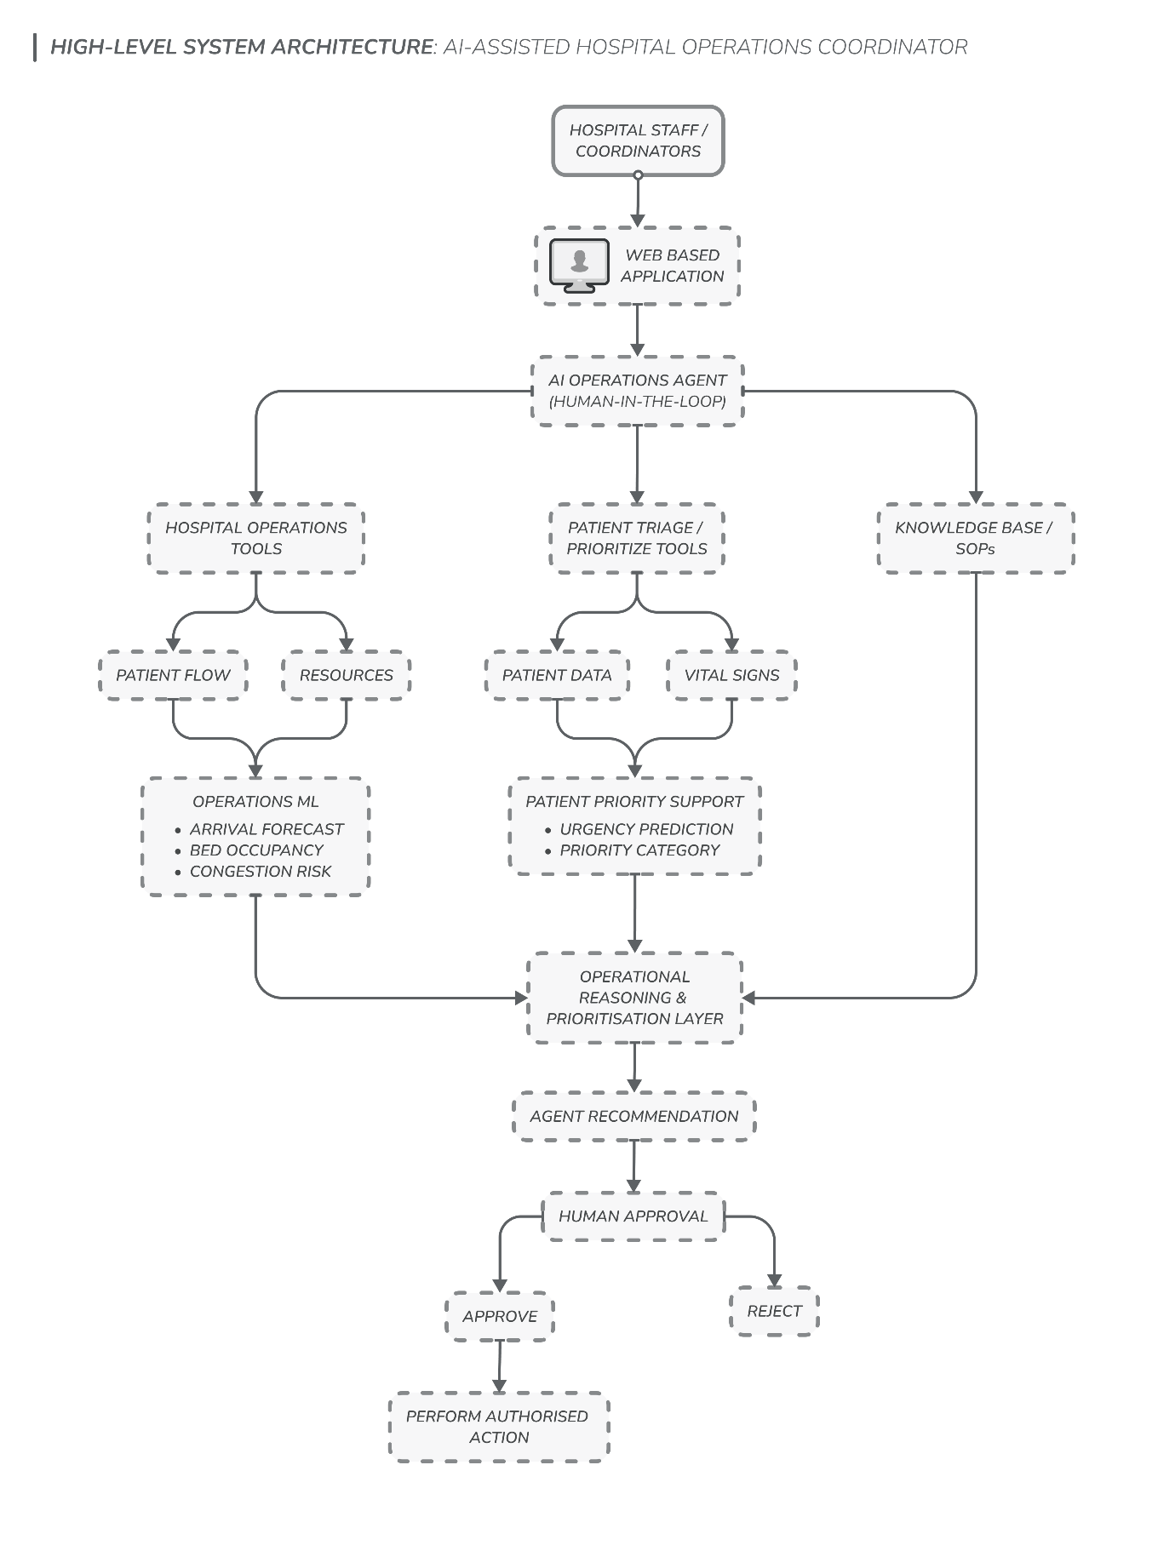
System Architecture (High Level)

AI-Based Patient Prioritisation/Triage Support Feature
What is Patient Triage?
Patient triage is the medical process of sorting and prioritising sick or injured patients based on how urgent their conditions are. It ensures that people with life-threatening conditions get care first, rather than being seen in the order they arrived.
How does this feature work?
- Data Input (of patient): Nurses (or digital kiosks) enter patient age, symptoms, pain level, heart rate, blood pressure, SpO₂, temperature, respiratory rate, and other vital signs.
- Risk Scoring: A machine-learning model analyses the recorded patient information and estimates an urgency category based on patterns learned from a labelled dataset.
- Sorting: The system generates a prioritisation recommendation for staff, who review and determine the final order of attention.
Note: The final decision remains with the healthcare professional.

Web App Blueprint
Our system has two roles now:
- Hospital Operations Coordinator
- Patient Triage Support
This web app is not just a dashboard, it is an interface that hospital staff use to monitor operations, review recommendations, interact with the agent, and to prioritise patients.
Web App Structure:
LOGIN
↓
DASHBOARD
|---- Patient Flow
|---- Patient Prioritisation
|---- Resource Management
|---- Recommendations
|---- Agent Activity
|---- History & Reports

Note: We will use a left-side vertical navigation bar (sidebar) to keep the above modules organised.

Deep Dive on Each Module
- Dashboard (Home Page)
The dashboard will show:
Patient Flow
- Current patient arrivals
- Patients currently waiting
- Average waiting time
Resource Status
- Overall bed occupancy
- Available beds
- ICU occupancy
Predictions
- Predicted patient arrivals
- Predicted bed occupancy
- Congestion risk
Alerts
- Critical/high-priority operational issues
Recommendations
- Number of pending recommendations
- Most important/current recommendation

- Patient Flow
This module will show:
- Patient arrivals
- Patients waiting
- Patients being treated
- Admissions
- Discharges
- Transfers
- Waiting-time trend
- Department-wise patient flow
Note: We can also show the same Patient Arrival Forecast as in the dashboard.

- Patient Prioritisation Support
This module will show:

Patient Information
- Patient ID
- Recorded vital signs
- Relevant patient information
- Current waiting time
ML Output
- Predicted triage/priority category
Resource Context
- Relevant available beds/resources
Agent Output
- Patient prioritisation recommendation
- Explanation/supporting factors

- Resource Management
This module will show:
Beds
- Total beds
- Occupied beds
- Available beds
- Occupancy %
ICU
- Total ICU capacity
- Occupied ICU beds
- Available ICU beds
- Predicted ICU occupancy
Other Resources (Optional)
- Important equipment availability

- Recommendations
Show each recommendation with:
- Problem detected
- Priority
- Supporting information
- Recommended action
- Reason (explanation)
- Timestamp
- Status

- Agent Activity
This page should show what the agent has done.
What information this module will show is yet to define.

- History & Reports (Optional)
This is optional for the first working version.
It shows:
- Past recommendations
- Approval/rejection status
- Actions taken
- Previous alerts
- Prediction records

